**Tugas Component dan Deployment Diagram Pizza**

**Kelompok :**

**Ikbar Nur Muhammad 1127050071 IF D**

**Fahmi Ahmad Jauhary 1127050052 IF C**

**Component Diagram**

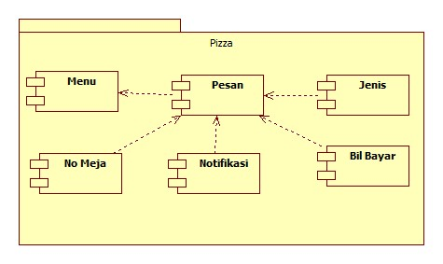

**Deployment Diagram** 